**Big Mountain Ski Resort**

**Data-driven insights regarding the company's pricing strategy**

1. The purpose of the project

The purpose of this project is to provide data-driven guidance on how to select a better value for Big Mountain Resort ticket price and test potential scenarios for implementing changes that would either cut operating costs or allow charging premium for tickets.

1. Research questions
2. Is the resort's current pricing strategy to base their pricing in the market's average adequate?
3. What resorts' features are people willing to pay extra for?
4. Where does Big Mountain Resort stand on these features, compared to competitors, and, given that information, how much it should be charging per ticket?
5. What would be the potential impact of the following scenarios on ticket price and revenue:
6. Permanently closing down up to 10 of the least used runs.
7. Increase the vertical drop by adding a run to a point 150 feet lower down but requiring the installation of an additional chair lift to bring skiers back up, without additional snow making coverage
8. Same as b) but adding 2 acres of snow making cover
9. Increase the longest run by 0.2 mile to boast 3.5 miles length, requiring an additional snow making coverage of 4 acres.
10. Methodology

Using a data set containing key information about all US resorts and their key characteristics, we built statistical models determining key resort features that predict ticket price. The models include linear regression and random forest model.

1. Results

RQ 1. We first explored what should be considered as 'a market' in the context of out business questions. The data indicated that all US resorts can be included into the definition of market; there were no substantial differences among states. Then we proceeded to testing average market price as a predictor of resorts' ticket price. The result indicated that basing ticket price on the market average would result, on average, in a $19 mismatch. In addition, the model fitted poorly explaining less than 1% of variance in ticket price meaning this is not an adequate strategy.

RQ2. Modeling resort price based off its features seemed to be a better strategy. Our models explained more than 70% in the ticket price. Based on our best fitting model, the following features seemed to be the most important: fast quads, runs, total area covered by snow machines, vertical drop, skiable terrain, and total chairs (see Fig. 1)

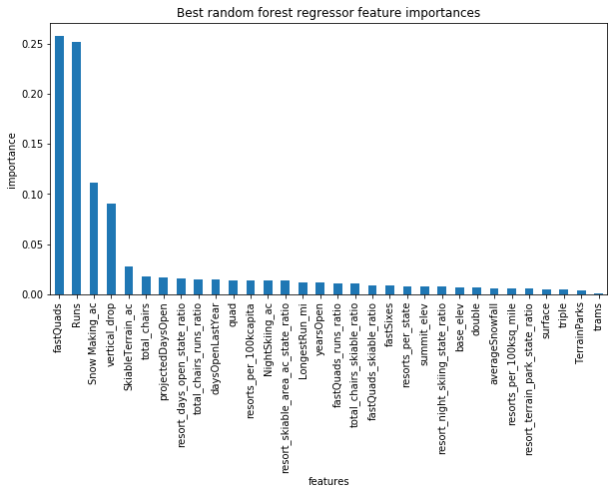

Figure 1. *Predictors of ticket price sorted by importance*

RQ 3. The plots below show resorts' distribution on the key features predicting ticket price. Red line indicates Big Mountain Resort's position in the distribution

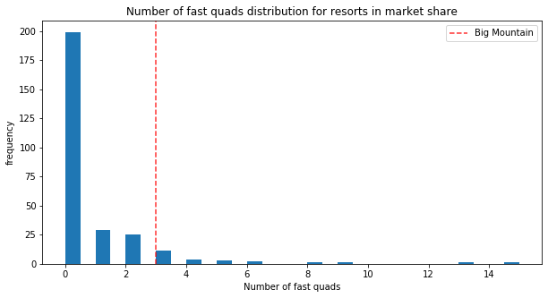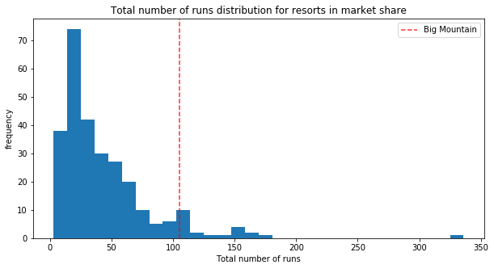

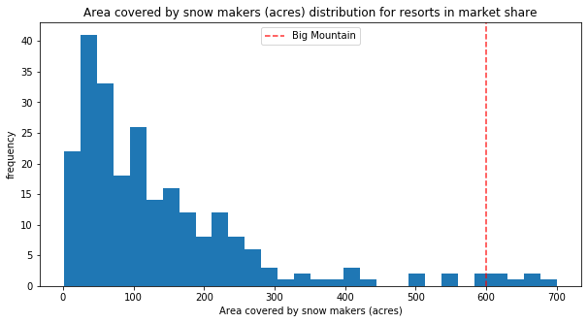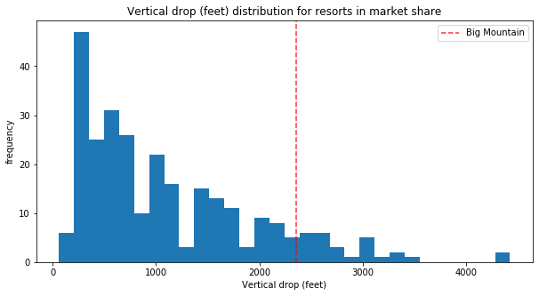

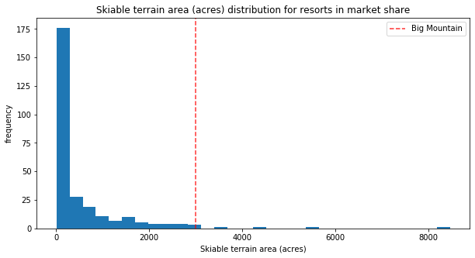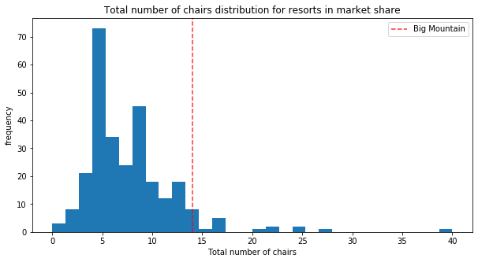

The chart suggests that Big Mountain Resort outperforms most competitors on all of these features. Our model suggested that the resort is currently underpricing itself. Big Mountain Resort modelled price is $94.22 whereas it actual price is $81.00. Even with the expected mean absolute error of $10.39, this suggests there is room for at least a $3 increase.

RQ4. Regarding the potential scenarios, closing down 1 run would not lead to a decrease in ticket price or revenue. If more runs need to be closed, 4 or 5 would be the optimal number as it minimally decreases ticket price and revenue (see Fig. 2)

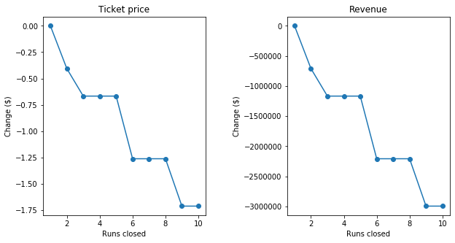

Figure 2. *The relationships between runs closed and ticket price (left) and revenue (right).*

Adding one run, increasing the vertical drop by 150 feet, and installing an additional chair lift would result in a ticket price increase by $1.99 and additional $3,474,638 in revenue, adding 2 extra acres of snow or increasing the longest run by .2 miles would not make a difference.

1. Conclusions

Without information on how much money closing a run would save, it is difficult to make exact recommendations on how many of them could be closed. One can be closed without affecting ticket price or revenue, closing more would depend on whether the resulting savings would be greater than expected losses in revenue. The resort can increase a ticket price by at least $3 without making any improvements; adding one run, increasing the vertical drop by 150 feet, and installing an additional chair would allow for an additional price increase in $1.99.